**Project Design Phase**

**Solution Architecture**

|  |  |
| --- | --- |
| Date | 12 February 2026 |
| Team ID | LTVIP2026TMIDS66080 |
| Project Name | IntelliSQL: Intelligent SQL Querying with LLMs Using Gemini Pro |
| Maximum Marks | 4 Marks |

**Solution Architecture:**

Solution Architecture bridges the gap between business needs and technical implementation. For **IntelliSQL**, the goal is to ensure a scalable, responsive, and secure Text-to-SQL system using **Streamlit**, **Python**, and **Google Gemini AI**, with clear data flow for administrators and non-technical users.

**Objectives of the Architecture:**

* **Define Component Interaction:** Establish how the Streamlit UI, Gemini API, and SQLite database interact.
* **Separation of Concerns:** Maintain clear boundaries between the UI, AI logic, and data storage.
* **Smooth Data Flow:** Enable rapid translation of natural language into SQL and immediate data retrieval.
* **Support Future Scaling:** Allow for easy upgrades to more powerful LLMs (e.g., Gemini Pro) or cloud databases.

**Architecture Layers and Components:**

|  |  |  |
| --- | --- | --- |
| **Layer** | **Components / Tools Used** | **Description** |
| **Frontend** | Streamlit, HTML/CSS | Web interface featuring a dark theme and sidebar navigation for Home, About, and Query pages. |
| **Backend** | Python, Google Generative AI SDK | Core logic for prompt engineering, SQL generation via Gemini Flash, and Regex-based sanitization. |
| **Database** | SQLite (data.db) | Local relational storage for the STUDENTS table including Names, Classes, Marks, and Companies. |
| **Security** | .env (python-dotenv) | Secure management of the GOOGLE_API_KEY to prevent exposure in source code. |
| **Dev Tools** | Git, VS Code, Regex | Development environment used for building, testing, and isolating valid SQL from AI responses. |

**Data Flow Summary**

1. **User Journey:**
   * User accesses dashboard → inputs natural language question → system attaches context prompt → Gemini generates SQL → Regex cleans query → data displayed in table.
2. **Admin/System Journey:**
   * System loads API key → initializes database connection → validates SQL commands against the STUDENTS table schema.

**Example - Solution Architecture Diagram:**

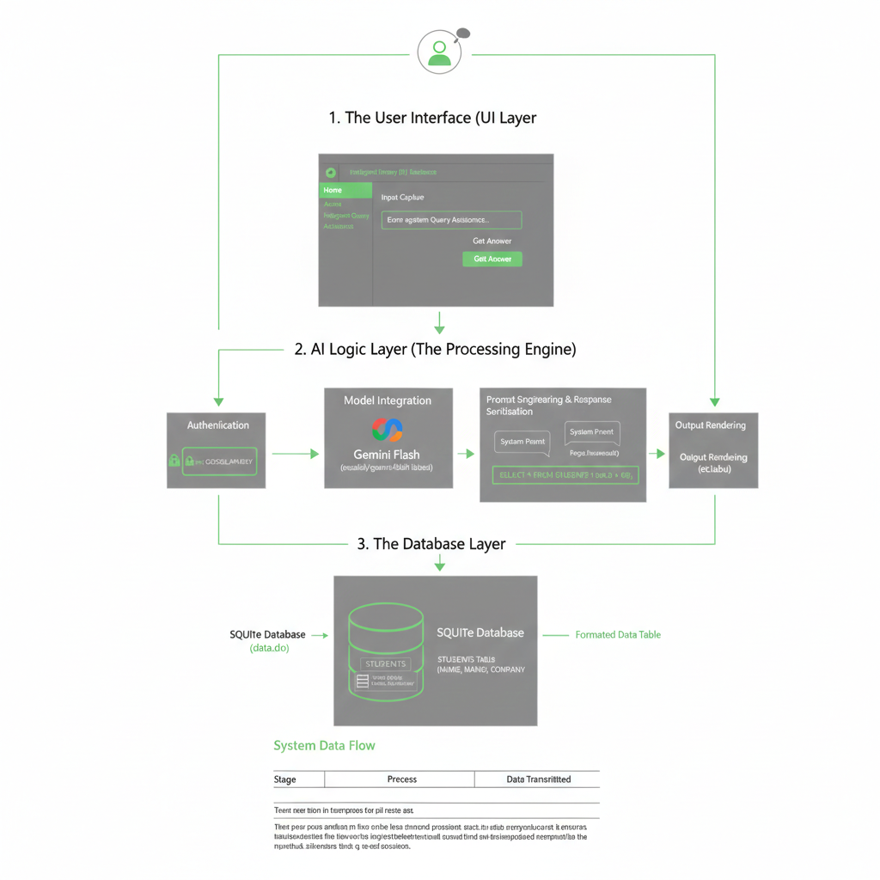

|  |  |  |
| --- | --- | --- |
| **Feature** | **Handled By** | **Status** |
| **Natural Language Processing** | Google Gemini Flash | ✔ Implemented |
| **SQL Extraction/Cleaning** | Python Regex (re) | ✔ Implemented |
| **Database Persistence** | SQLite | ✔ Implemented |
| **Secure Key Handling** | .env, python-dotenv | ✔ Implemented |
| **Modular UI Navigation** | Streamlit Sidebar | ✔ Implemented |
| **Performance Optimization** | Gemini 1.5 Flash Model | ✔ Optimized |

**Notes:**

* The current design supports future enhancements like multi-table joins, voice-to-query integration, and export-to-CSV features.
* The modular 3-tier architecture ensures that the database can be migrated to a cloud-based SQL server (e.g., PostgreSQL) without rewriting the AI logic.